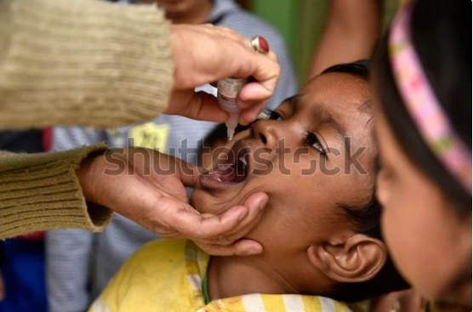

Immunization is one of the most effective methods of preventing childhood communicable diseases

13.9 Million Number of children who did not receive a single dose of vaccine

Immunization link solution

By linking the clients contacts with the hospitals data base, we hope to:

1. Send texts to clients about their immunization dates
2. Update immunization records and link them to the MoH HMIS
3. Updates can be done in any hospital if the client has travelled and or visited another health facility.

 Our Team: Comprises of a data base creation expert, a community and clinical nurse.



We are asking for 30,000 USD to pilot this project in 10 health centres in Nairobi County. We hope to sell this idea to UNICEF to scale up this idea.

beckynyokabi@gmail.com